What is adequate screening, and what controls visual quality?

Mn/DOT standards for screening are 100% to 97% for structural screening would allow 1/8” gaps between boards on wood fences which over time will shrink to about ¼” gap; and two directional diagonal slats are required for chain link fences. Landscape screening should be a minimums of three rows deep and should be sized and shaped, so that they provide 60% effective screening in five years and achieve 95% screening effective screening in 12 years. This requires that adequate watering and maintenance be provided to ensure adequate growth and survival. To determine if proposed screening will do the job, the preparation of a site line study for each project is required. Using the diagram below, a simple calculation will ensure adequate screening.

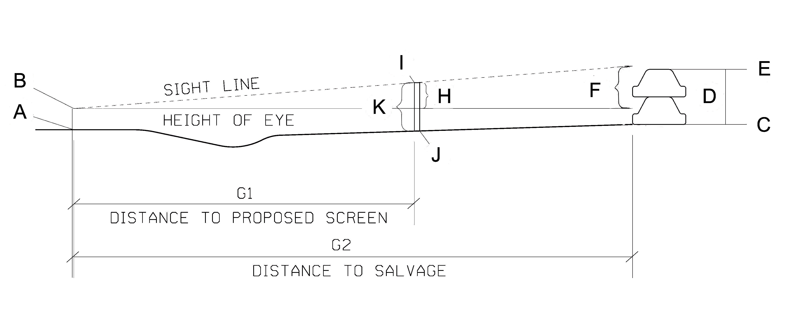

Definition of Terms

A = elevation at centerline of road
B = elevation at centerline of road plus 3.5ft to establish height of eye
C = ground elevation at the base of highest point of salvage
D = maximum height of salvage
E = elevation at the top of the salvage
F = the height of salvage located above the elevation at height of eye
G1 = Distance from road centerline to location of proposed screen
G2 = distance from road centerline to highest point of salvage
H = the difference in elevation between point I and point B
I = required elevation at top of proposed screen
J = existing ground elevation at proposed screen
K = difference between elevation at top of proposed screen at point I and groundline below screen at point J
Equations

Solve for elevation at top of screen
(F x G1) + G2 = H
H + B = I
Solve for height of screen
I - J = K

Example Calculation

Given B = 1235.0 G1 = 150ft J = 1228.0
E = 1225.0 G2 = 250ft

Elevation at the top of the screen
(10 x 150) + 250 = 6ft
6 + 1235.0 = 1241.0
Height of screen
1241.0 – 1228.0 = 13ft

