Summary of the Fatigue Characterization Test for
MnROAD PPA Modified Mixtures

Introduction
TFHRC received a total of four loose mixes from MnROAD in October 2007. Table 1 lists the mixture identification and binder modification.

Table 1 Mixture and Binder Modification

Mixture ID | Binder Modification
A | PPA modified only
AE | PPA and Elvaloy polymer modified
SBS | SBS polymer modified only
SBSA | SBS polymer and PPA modified

Sample Preparation and Test Procedure
The fatigue characterization test was performed at TFHRC for all these four mixtures. The loose mix was reheated and compacted using the Superpave gyratory compactor to 150mm in diameter and 180mm in height with a target air voids of 7%. Only the gyratory compacted samples that are within 7±0.5% air voids were then used to core and cut into specimens with 72mm diameter and 150mm high. The test specimen was then glued to the test platen with epoxy, as is shown in Error: Reference source not found. Three LVDTs were mounted on the specimen with a gauge length of 75mm to measure the displacement during testing.

The push- pull fatigue tests were performed at 19ºC with a MTS servo-hydraulic testing system. The TestStar IIs control system was used to set up and perform the tests and to collect the data. The software package MultiPurpose TestWare was used to custom-design the tests and collect the data. All tests were performed inside an environmental chamber for temperature control. Liquid nitrogen tanks were used to obtain the required low temperature. The air temperature of the chamber was controlled by a MTS temperature controller and verified using an independent platinum RTD thermometer. Prior to testing, the samples were kept in the environmental chamber at the test temperature for two hours to avoid any temperature gradient within the sample. A constant actuator strain value of 500με was used to control the test. The fatigue test was executed at 10Hz and testing ceased when the specimen failed.
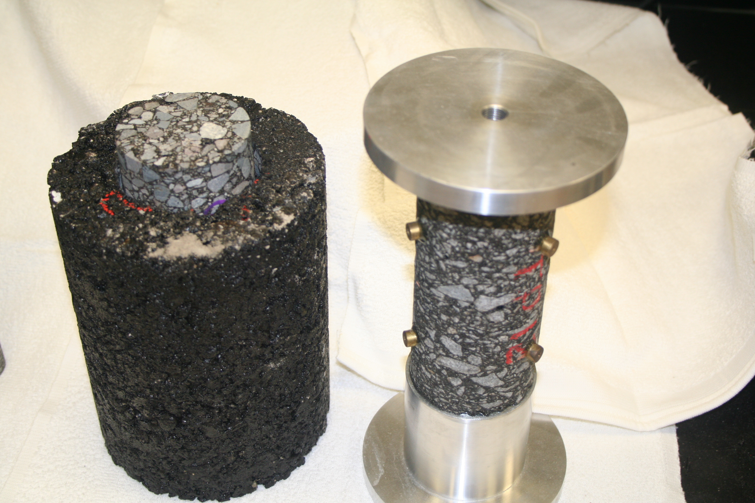

Figure 1 Push-pull Fatigue Test Specimen

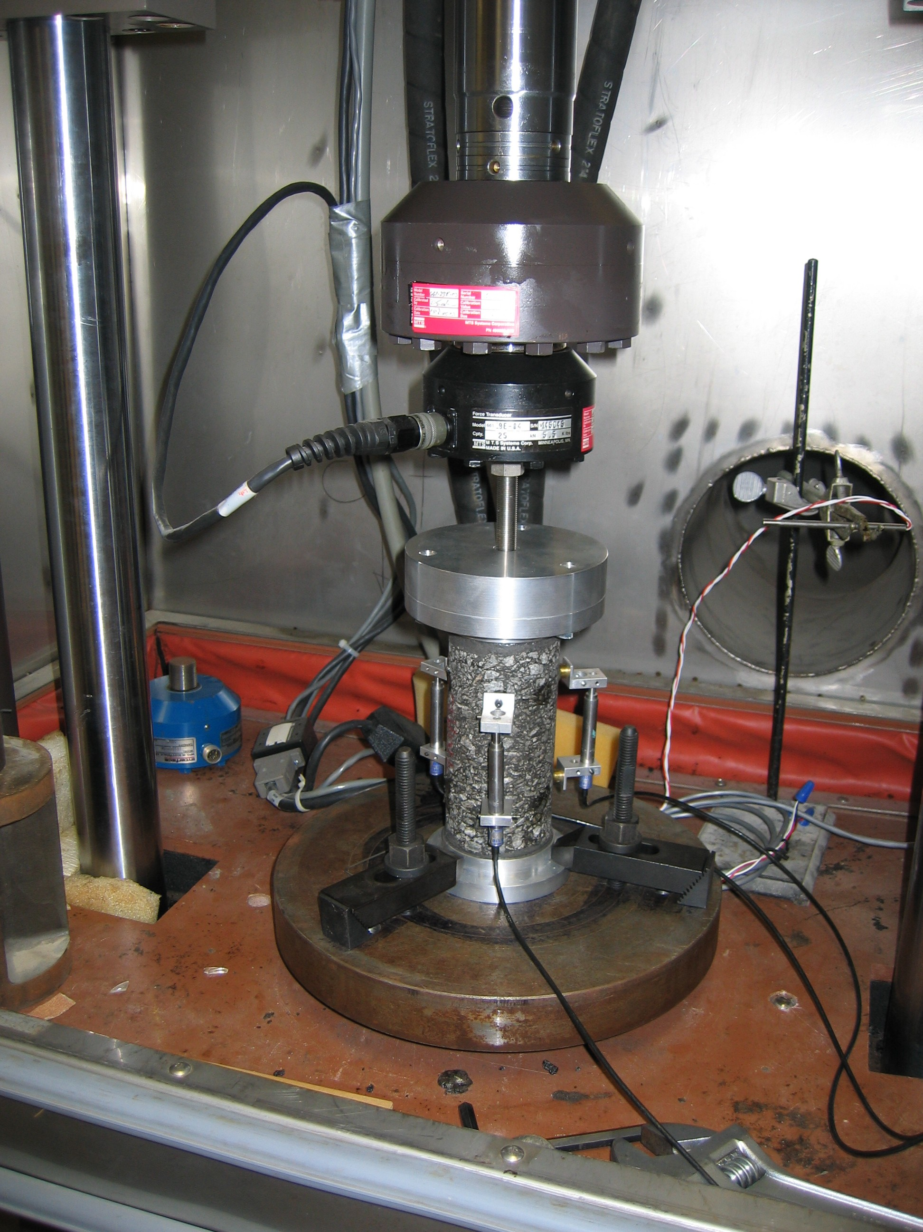

Figure 2 Push-pull Fatigue Test Setup
Experimental Results and Discussion
During the fatigue test, the axial force was recorded and the displacements were measured by the three mounted LVDTs. The dimensions including the height and diameter of the specimen were measured before testing. Consequently, the axial stress and three strain values were obtained in the push-pull test. The push-pull is an uni-axial tension and compression test and the stress is theoretically evenly distributed within the loaded specimen. The dynamic modulus can be calculated by using the axial stress divided by the average of the three strains. The dynamic modulus can also be obtained for each LVDT by dividing the axial stress by the corresponding LVDT measured strain (displacement). The overall dynamic modulus of the specimen can then be obtained by averaging these three dynamic modulus values obtained from each LVDT. The dynamic modulus values obtained using both methods were presented and discussed in this report. Although not significant different was observed for these two method, the dynamic modulus calculated using the averaged strain is used for all mixtures to get the load cycles that equal to 50% dynamic modulus loss.
The experimental results including the dynamic modulus and phase angle are discussed and plotted for each mixture.

Mixture with PPA only

Figures 3 to 6 show the experimental results for the mixture with PPA only. Figure 3 presents the dynamic modulus values obtained from two different methods and no significant difference was found for these two methods.

Figure 3 Dynamic Modulus for the Mixture with PPA only

Figure 4 shows the dynamic modulus obtained using the average strain from the three LVDTs. The error bar shown in Figure 4 is the standard deviation of the four replicates. It can be seen that the variation increases with the load cycles.

Figure 4 Variation of Dynamic Modulus for the Mixture with PPA only

Figure 5 shows the load cycle that equals to 50% of the initial dynamic modulus. It was found that when an average of 3800 cycles were loaded, the dynamic modulus of test specimens modified with PPA only was 50% of the initial values.

Figure 5 Cycles Equal to 50% Dynamic Modulus for the Mixture with PPA only
Figure 6 shows the average phase angle of the four test specimens. It can be found that the phase angle was significantly increased at the beginning of the load cycles and then increased slightly. Similarly, it was found the variation of the phase angle increases with load cycles.
Figure 6 Phase Angle for the Mixture with PPA only

PPA and Elvaloy Polymer

Figures 7 to 10 show the experimental results for the mixture modified with PPA and Elvaloy polymer. Figure 7 presents the dynamic modulus values obtained from two different methods and no notable difference was found for these two methods.

Figure 7 Dynamic Modulus for the Mixture with PPA and Elvaloy Polymer

Figure 8 shows the dynamic modulus obtained using the average strain from the three LVDTs. The error bar shown in Figure 8 is the standard deviation of the four replicates. It can be seen that the variation increases with the load cycles, as is consistent with the mixture modified with PPA only.

Figure 8 Variation of Dynamic Modulus for the Mixture with PPA and Elvaloy Polymer

Figure 9 shows the load cycle that equals to 50% of the initial dynamic modulus. It was found that when an average of 3740 cycles were loaded, the dynamic modulus of test specimens modified with PPA only was 50% of the initial values.
Figure 9 Cycles Equal to 50% Dynamic Modulus for the Mixture with PPA and Elvaloy Polymer

Figure 10 shows the average phase angle of the four test specimens. The phase angle was found to be very similar to that of the mixture modified with PPA only.
Figure 10 Phase Angle for the Mixture with PPA and Elvaloy Polymer
SBS Polymer only

Figures 11 to 14 show the experimental results for the mixture modified with SBS polymer only. Similarly, Figure 11 shows no obvious difference between these two different methods.
Figure 11 Dynamic Modulus for the Mixture with SBS only

Figure 12 shows the dynamic modulus obtained using the average strain from the three LVDTs. The error bar shown in Figure 12 is the standard deviation of the four replicates. A relatively constant variation was found with the load cycles, as is different from the PPA modified mixture and PPA and Elvaloy polymer modified mixture.
Figure 12 Variation of Dynamic Modulus for the Mixture with SBS Only
Figure 13 shows the load cycle that equals to 50% of the initial dynamic modulus. A high load repetition of 6750 cycles was found to produce a 50% loss of the initial dynamic modulus, as is much higher that from both the PPA modified and PPA and Elvaloy polymer modified mixtures.

Figure 13 Cycles Equal to 50% Dynamic Modulus for the Mixture with SBS only

Figure 14 shows the average phase angle of the four test specimens. The phase angle was found to be very similar to those from both the PPA modified and PPA and Elvaloy polymer modified mixtures.
Figure 14 Phase Angle for the Mixture with SBS only
SBS Polymer and PPA

Figures 15 to 18 show the experimental results for the mixture modified with SBS polymer and PPA. Similarly, Figure 15 shows no obvious difference between these two different methods.
Figure 15 Dynamic Modulus for the Mixture with SBS Polymer and PPA

Figure 16 shows the dynamic modulus obtained using the average strain from the three LVDTs. The error bar shown in Figure 16 is the standard deviation of the four replicates. It was found that the variation of dynamic modulus decreases with the load repetition, as is different from the other three mixtures.
Figure 16 Variation of Dynamic Modulus for the Mixture with SBS Polymer and PPA
Figure 17 shows the load cycle that equals to 50% of the initial dynamic modulus. Again, a relatively high load repetition of 6400 cycles was found to produce a 50% loss of the initial dynamic modulus, as is much higher that from both the PPA modified and PPA and Elvaloy polymer modified mixtures but slightly lower than that from the SBS polymer modified mixture.

Figure 17 Cycles Equal to 50% Dynamic Modulus for the Mixture with SBS Polymer and PPA

Figure 18 Phase Angle for the Mixture with SBS Polymer and PPA
Figure 18 shows the average phase angle of the four test specimens. The phase angle was found to be very similar to those from the other three mixtures.

Comparison

The fatigue life of the tested specimens is listed in Table 2. Average value and standard deviation were calculated based upon the modifier category, as is plotted in Figure 19 for comparison.

Table 2 Fatigue Life of the Test Specimens without VECD

Modifier | Specimen ID | Fatigue Cycle | Average | Standard Deviation
PPA Only | A1 | 40200 | 49575 | 9809
PPA Only | A3 | 42900 | 49575 | 9809
PPA Only | A4 | 53900 | 49575 | 9809
PPA Only | A5 | 61300 | 49575 | 9809
PPA and Elvaloy | AE1 | 67800 | 55750 | 8556
PPA and Elvaloy | AE2 | 55200 | 55750 | 8556
PPA and Elvaloy | AE5 | 48000 | 55750 | 8556
PPA and Elvaloy | AE6 | 52000 | 55750 | 8556
SBS Only | SBS2 | 183600 | 206200 | 40059
SBS Only | SBS3 | 205900 | 206200 | 40059
SBS Only | SBS6 | 172700 | 206200 | 40059
SBS Only | SBS7 | 262600 | 206200 | 40059
SBS and PPA | SBSA1 | 117800 | 120575 | 27365
SBS and PPA | SBSA3 | 90600 | 120575 | 27365
SBS and PPA | SBSA4 | 116900 | 120575 | 27365
SBS and PPA | SBSA5 | 157000 | 120575 | 27365

As can be found from Figure 19, the PPA modified mixture has the smallest fatigue life while both the PPA and Elvaloy polymer modified mixture has a slightly higher fatigue life. The mixture modified with SBS polymer was found to have the highest fatigue life of more than 200,000 cycles whereas the mixture modified with both SBS polymer and PPA was found to have a much lower fatigue life.

Figure 19 Fatigue Life without VECD

Figure 20 plots the load cycles that equal to 50% of the initial dynamic modulus. The PPA modified mixture and PPA and Envaloy modified mixture were found to have very close load cycles for 50% drop of the initial dynamic modulus. The SBS polymer modified mixture was found to have the highest load cycles for 50% loss of the initial dynamic modulus but only slightly higher than that from the SBS and PPA modified mixture. It should be noted that the rank of the mixture is the same for the fatigue life and the load cycles equal to 50% dynamic modulus drop.

Figure 20 Load Cycles Equal to 50% of the Initial Dynamic Modulus

